**CSA1072 Software Engineering**

**NAME: Cherukuri sai murali**

**Reg number: 192211951**

EXPERIMENT NUMBER 1: Draw and validate Flowchart to compute quotient and remainder between two integers can be calculated by using the division ( / ) and modulus ( % ) operators respectively. To compute the remainder of the division of two floating point numbers, the library function fmod() is used. This function considers quotient as an integer number and the remainder as a floating-point number.

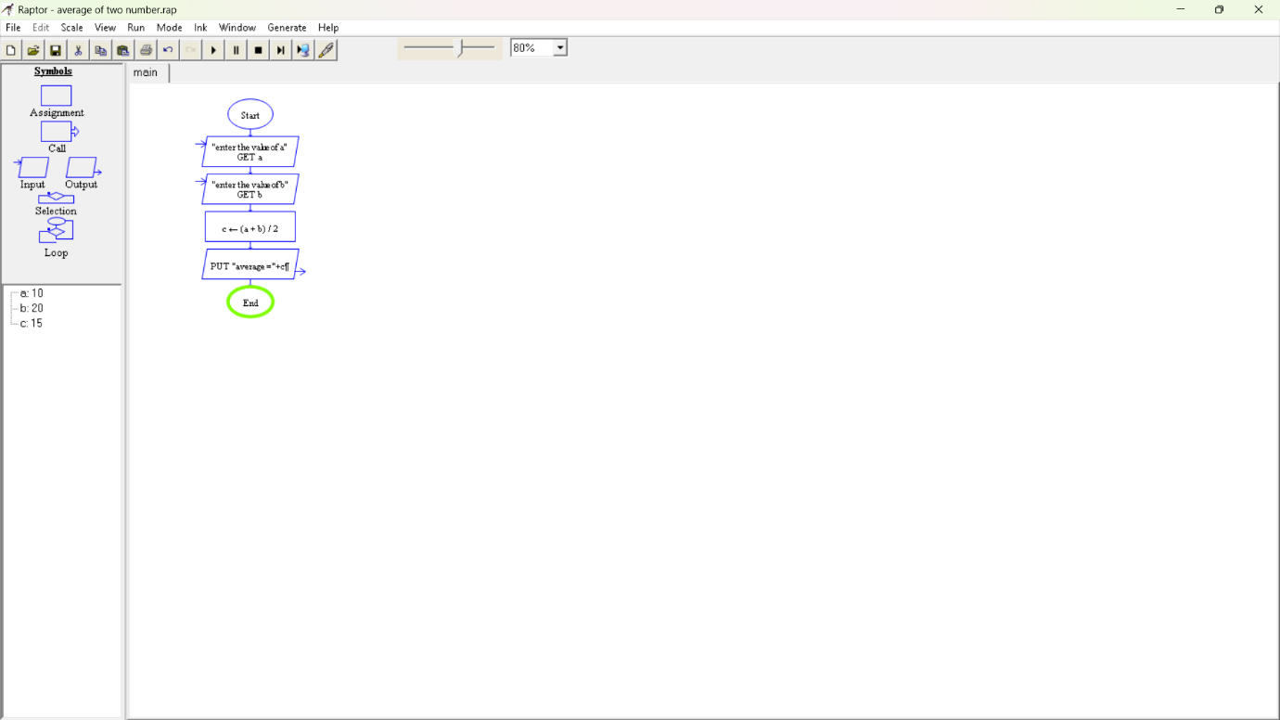

EXPERIMENT NUMBER 2: Using Raptor- Draw the flowchart to check whether the given number is a palindrome or not. This scenario is a word, number, phrase, or other sequence of symbols that reads the same backwards as forwards. AdaptA method for this problem is to reverse digits of number, compare the reverse of number. If both are same, then return true, else false using Raptor tool.

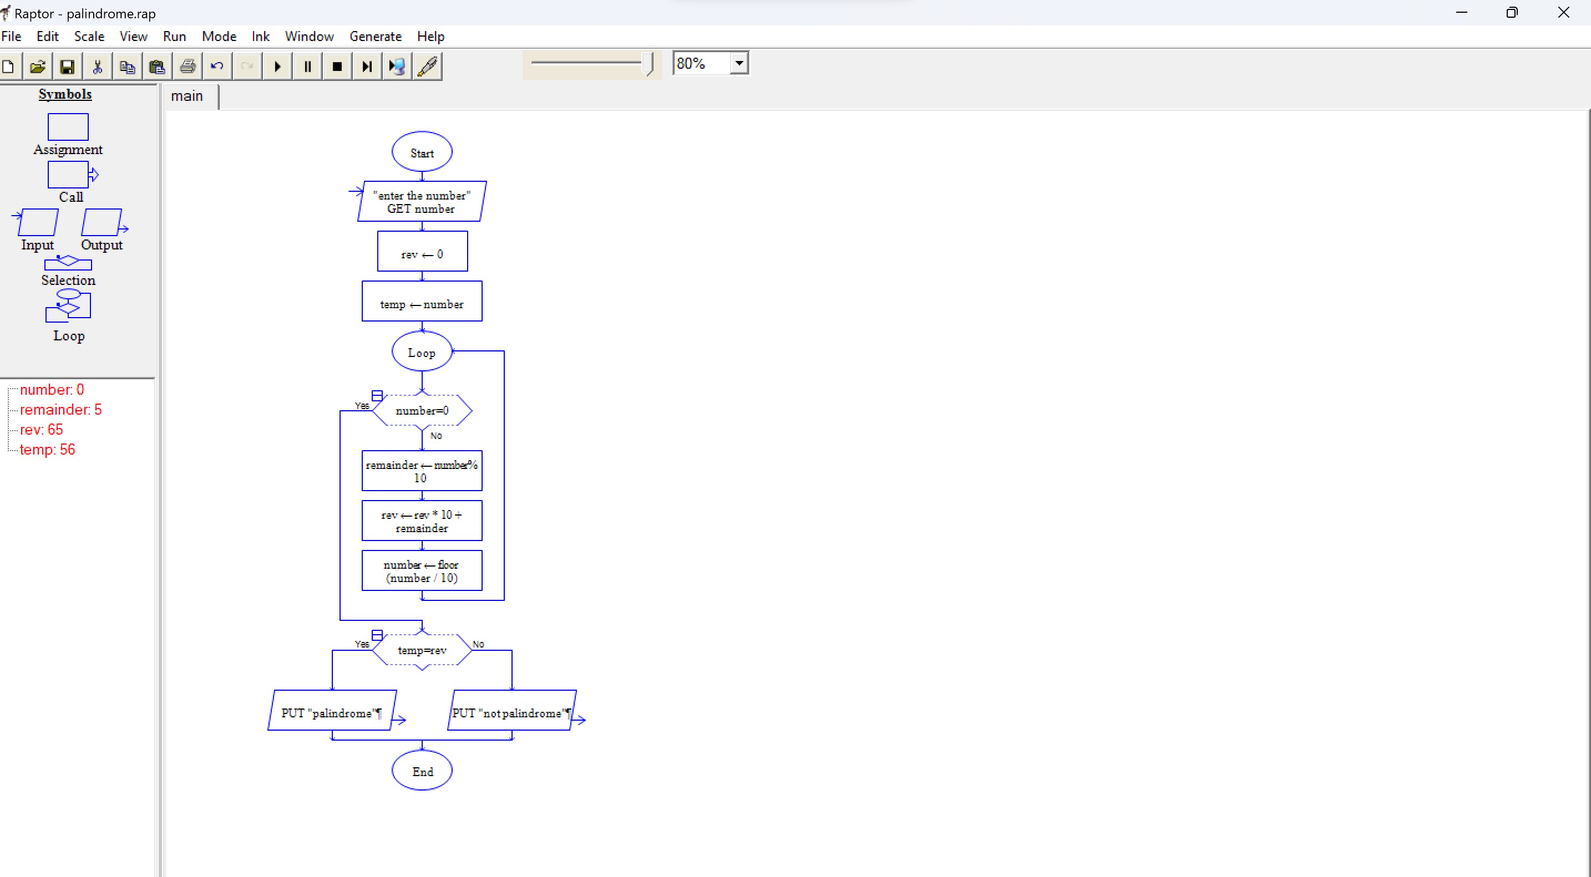

EXPERIMENT NUMBER 3: Take for example the RSA encryption system: All arithmetic is done modulo n, with n=pq and p, q large primes. Decryption in this system relies on computing Euler's phi function, φ(n), which is hard to compute (hence the system is hard to break) **unless** you know the prime factorization of n (which is also hard to compute unless you know it upfront). Hence you need a method to generate primes (the Miller-Rabin primality checking algorithm is usually used here) and then you construct n by multiplying the primes you have found. Using Raptor, draw the flowchart to find whether p and q are prime or not.

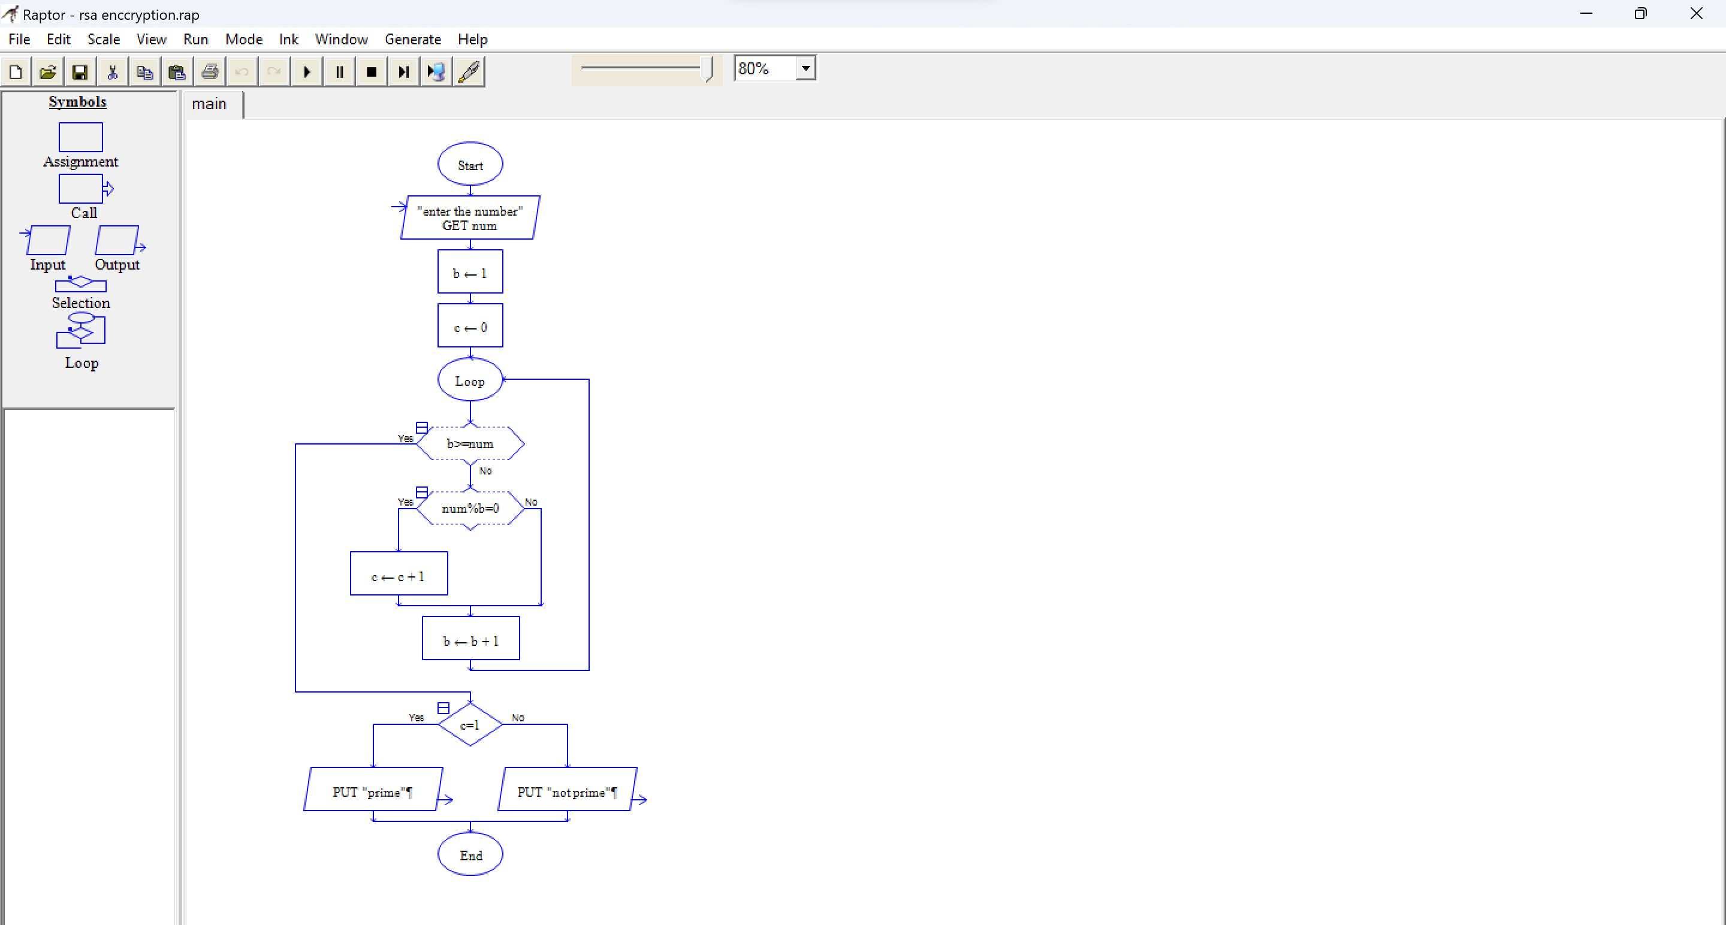

EXPERIMENT NUMBER 4: Using Raptor- Draw and validate the flowchart to calculate Factorial of a number. Factorial of a positive integer (number) is the sum of multiplication of all the integers smaller than that positive integer. For example, factorial of 5 is 5 * 4 * 3 * 2 * 1 which equals 120.

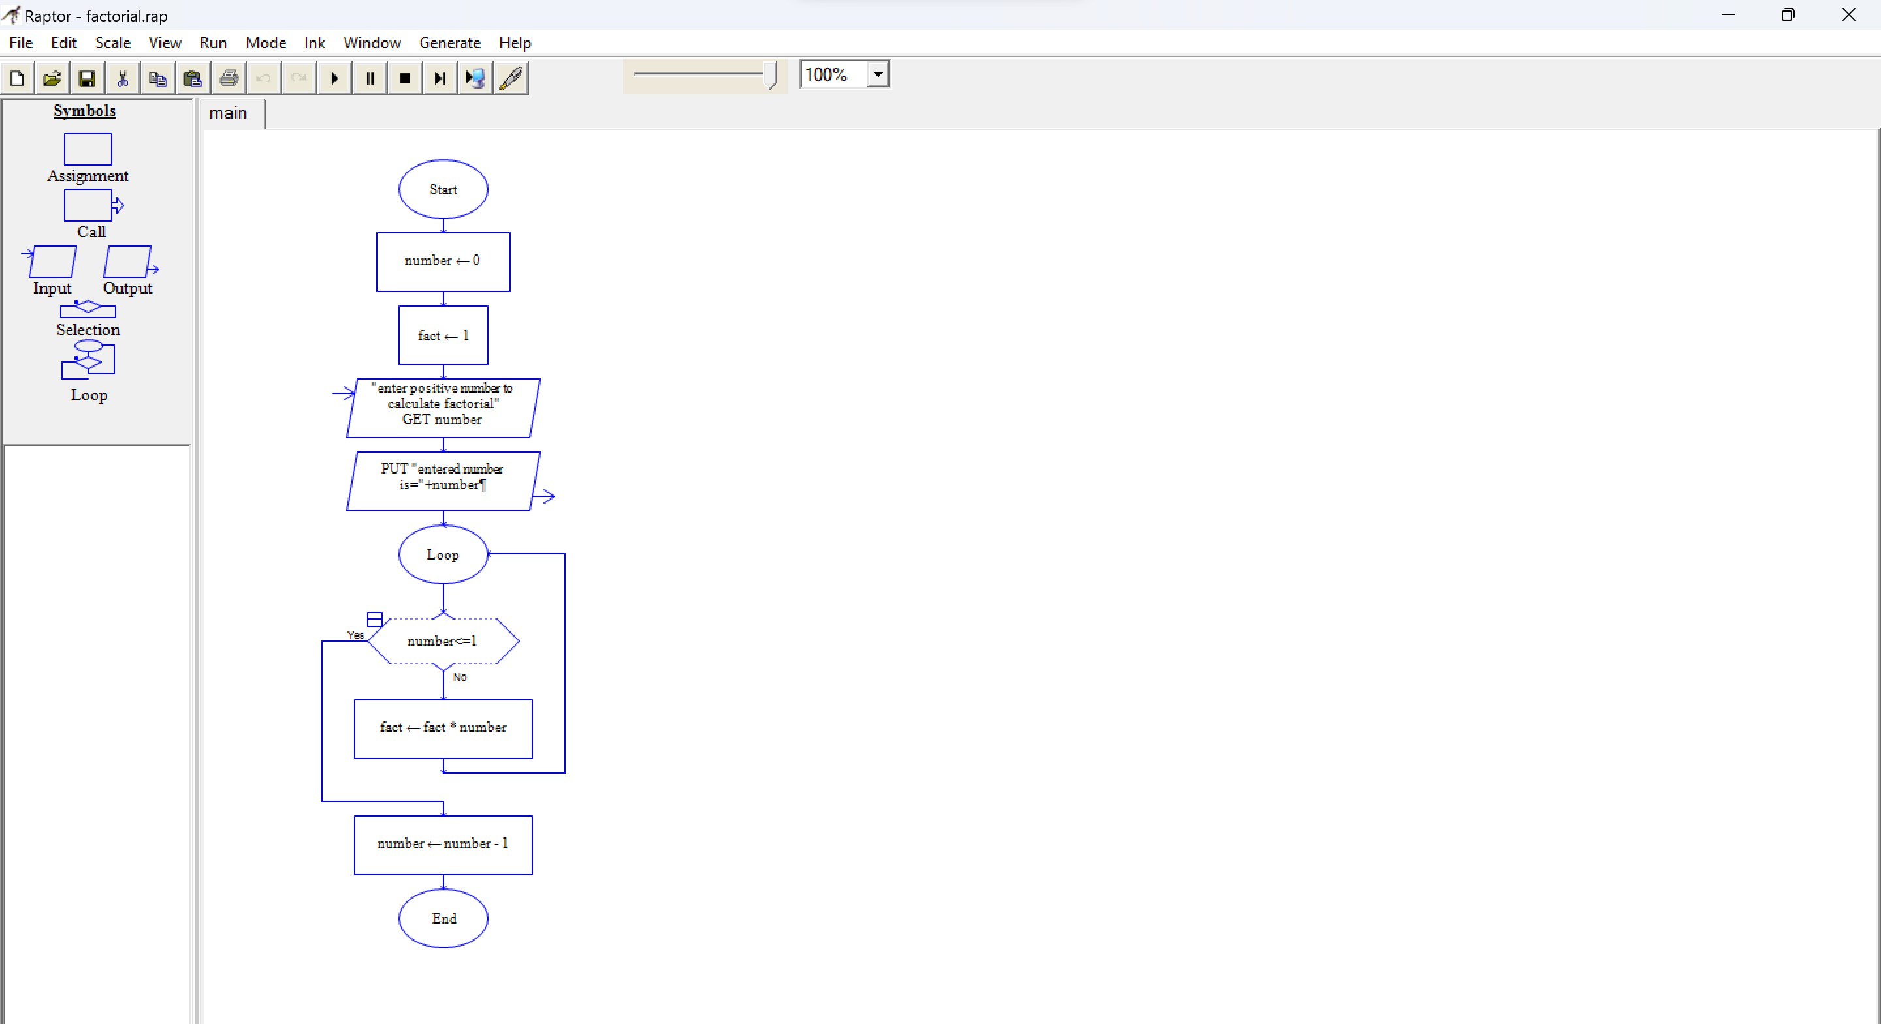

EXPERIMENT NUMBER 5: Using Raptor – Draw and validate the flowchart to find odd series of the given number. The odd numbers are the numbers which are not divisible by 2. They are 1,3,5,7,9,11,13,15,17,19 etc.. Using Raptor – Draw and validate the flowchart to find even series of the given number

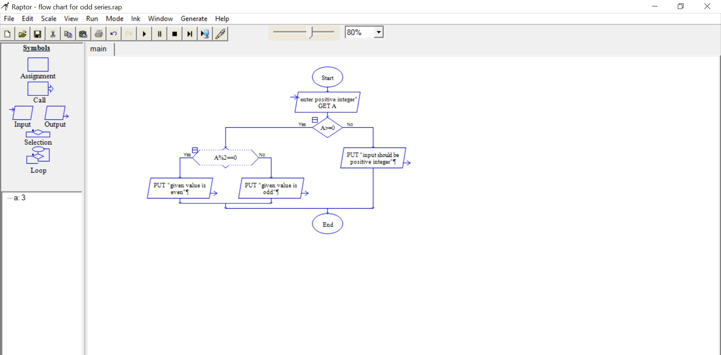

EXPERIMENT NUMBER 6: Draw the flowchart that uses Raptor, how to reverse a given String. If the string is "hello" then, the output should be "olleh". We can use this concept to check the palindrome. Because the palindrome string will have the same value even after we reverse it.

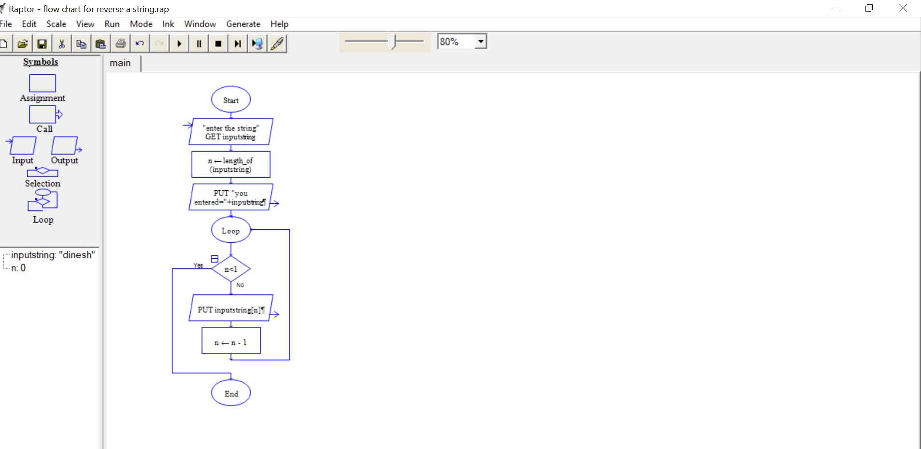

EXPERIMENT NUMBER 7: Draw the flowchart using Raptor, The formula of the sum of first n natural numbers is S=n(n+1)2S=n(n+1)2 . If the sum of first n natural number is 325 then find n. Using Raptor – Draw the flowchart to find largest of n numbers

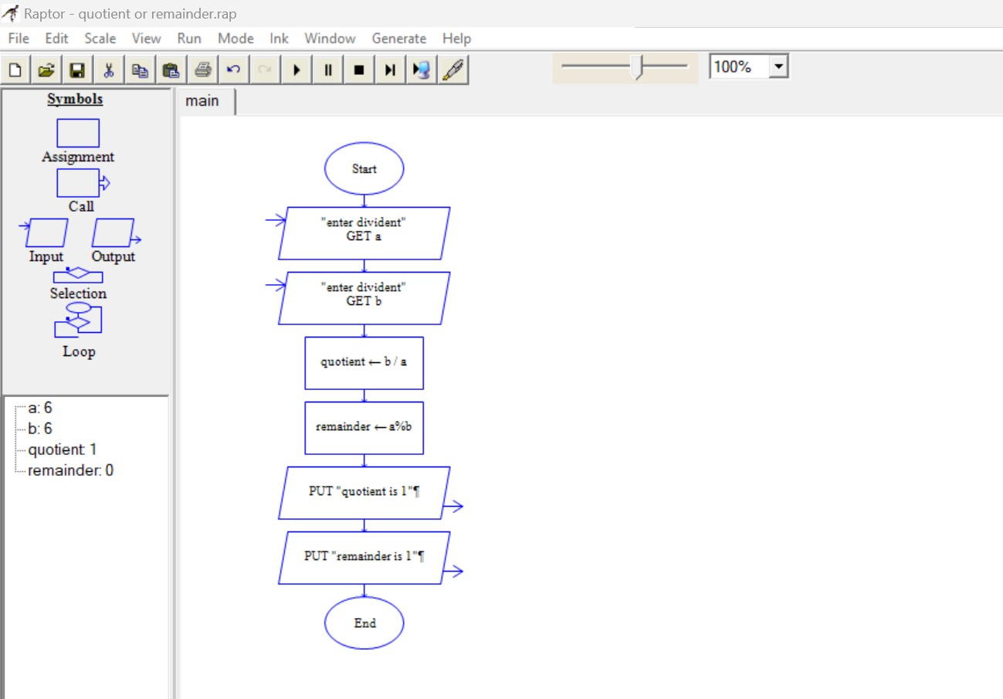

EXPERIMENT NUMBER 8: Using Raptor- Draw and validate the flowchart to calculate Fibonacci Series which plays a big part in Western harmony and musical scales. Here are the facts: An octave on the piano consists of 13 notes. Eight are white keys and five are black keys. A scale is composed of eight notes, of which the third and fifth notes create the foundation of a basic chord. In a scale, the dominant note is the fifth note, which is also the eighth note of all 13 notes that make up the octave. Eight divided by 13 equals 0.61538 the approximate Golden Ratio. Using Raptor, draw and validate the flowchart.

